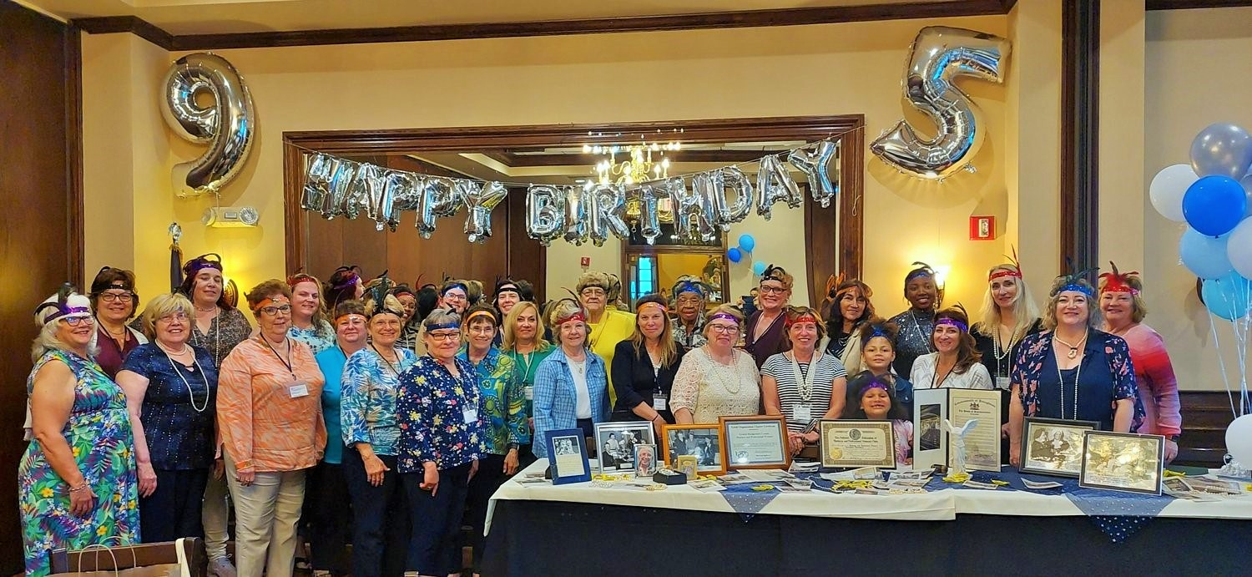
CMC BPW has dedicated more than 95 years to serving the women of our communities, advocating on behalf of women in the workforce. We are
“The Voice of Working Women”
CMC BPW is a diverse group, working together to promote the interests of business and professional women; bring about a spirit of cooperation; and extend opportunities through education.
CMC BPW is part of the Pennsylvania Federation of Business and Professional Women (BPW/PA). Learn more here: www.bpwpa.org.
CMC BPW 2023-2024 Officers:
Mo Gillen, President
Becky Shoulberg, Vice President
Mercedes Petrellis, Recording Secretary
Trish Corvo, Corresponding Secretary
Noreen Morello, Treasurer
Contact us at cmcbpw@gmail.com.

Dinner & lunch meetings are held at Maggiano’s Little Italy, King of Prussia.
Dinner is $40; lunch is $35.
RSVP to cmcbpw@gmail.com.
September 21, 2023 (dinner meeting)
Scholarship Awards to Montgomery County Community College (MCCC)
October 19, 2023 (daytime event)
Community Service Project:
Sleeping Mats at Norristown Library
November 16, 2023 (Zoom meeting)
Veterans & Public Service Recognition
December 3, 2023 (Sunday afternoon)
HOLIDAY BINGO - Annual Fundraiser
February 15, 2024 (Zoom meeting)
Black History Month Commemoration
March 14, 2024 (evening event)
Community Event:
Equal Pay Day “UnHappy Hour”
March 21, 2024 (lunch meeting)
Women’s History, Equal Pay Day, & Legislative Initiatives
May 16, 2024 (Zoom meeting)
CMC BPW Annual Meeting
Financial Empowerment
Supporting Members & their Businesses
June 20, 2024 (dinner meeting)
Supporting our Local Community,
incl Cribs 4 Kids Montgomery County

To acquire skills and knowledge that will benefit you individually!
To grow personally & professionally.
To learn more about issues affecting women in the workplace, including:
- Equal Rights Amendment
- Economic Equity & Fair Pay
- Women’s Health Issues
- Eliminating sexual harassment and discrimination, and protecting earned civil rights
You will participate and have a voice in programs and projects that BPW supports in Montgomery County and throughout Pennsylvania.
You will actively influence legislation on issues that are important to women and children.
You will make new friends with women of diverse backgrounds.
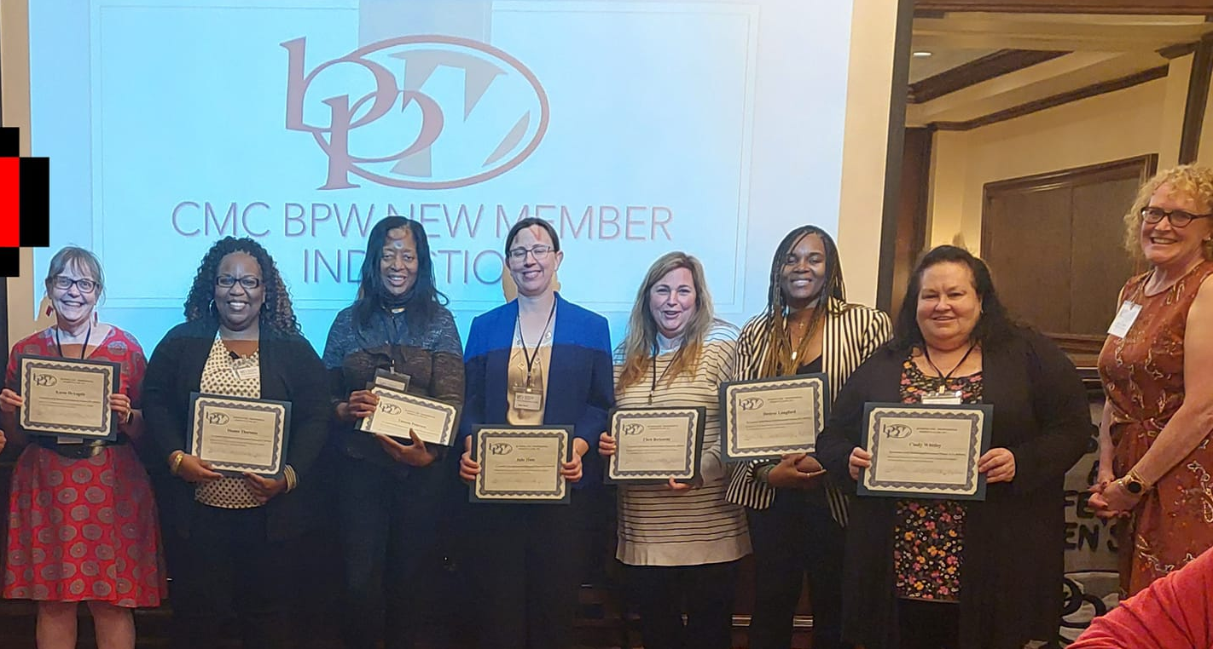

Become a member on line via PayPal, at www.centralmontgomerycountybpw.org

Or complete the Membership Form below.
Send with your check for $50 annual dues ($20 for students), payable to
Central Montgomery County BPW
Send to: Noreen Morello, Treasurer
504 E. Fornance St.
Norristown, PA 19401
__________________________________
Name

__________________________________
Street Address/P.O. Box

__________________________________
City, State, Zip Code

__________________________________
Home Phone

__________________________________
Cell Phone

__________________________________
Work Phone

__________________________________
Email Address

__________________________________
Occupation

__________________________________
Employer

__________________________________
Birth Month/Day
Questions?
Contact us at cmcbpw@gmail.com.
CMC BPW offers:
Networking, Mentoring, and Professional Development
Community Involvement
Women of the Year & Employer of the Year Awards
Scholarship Awards
Legislative Initiatives
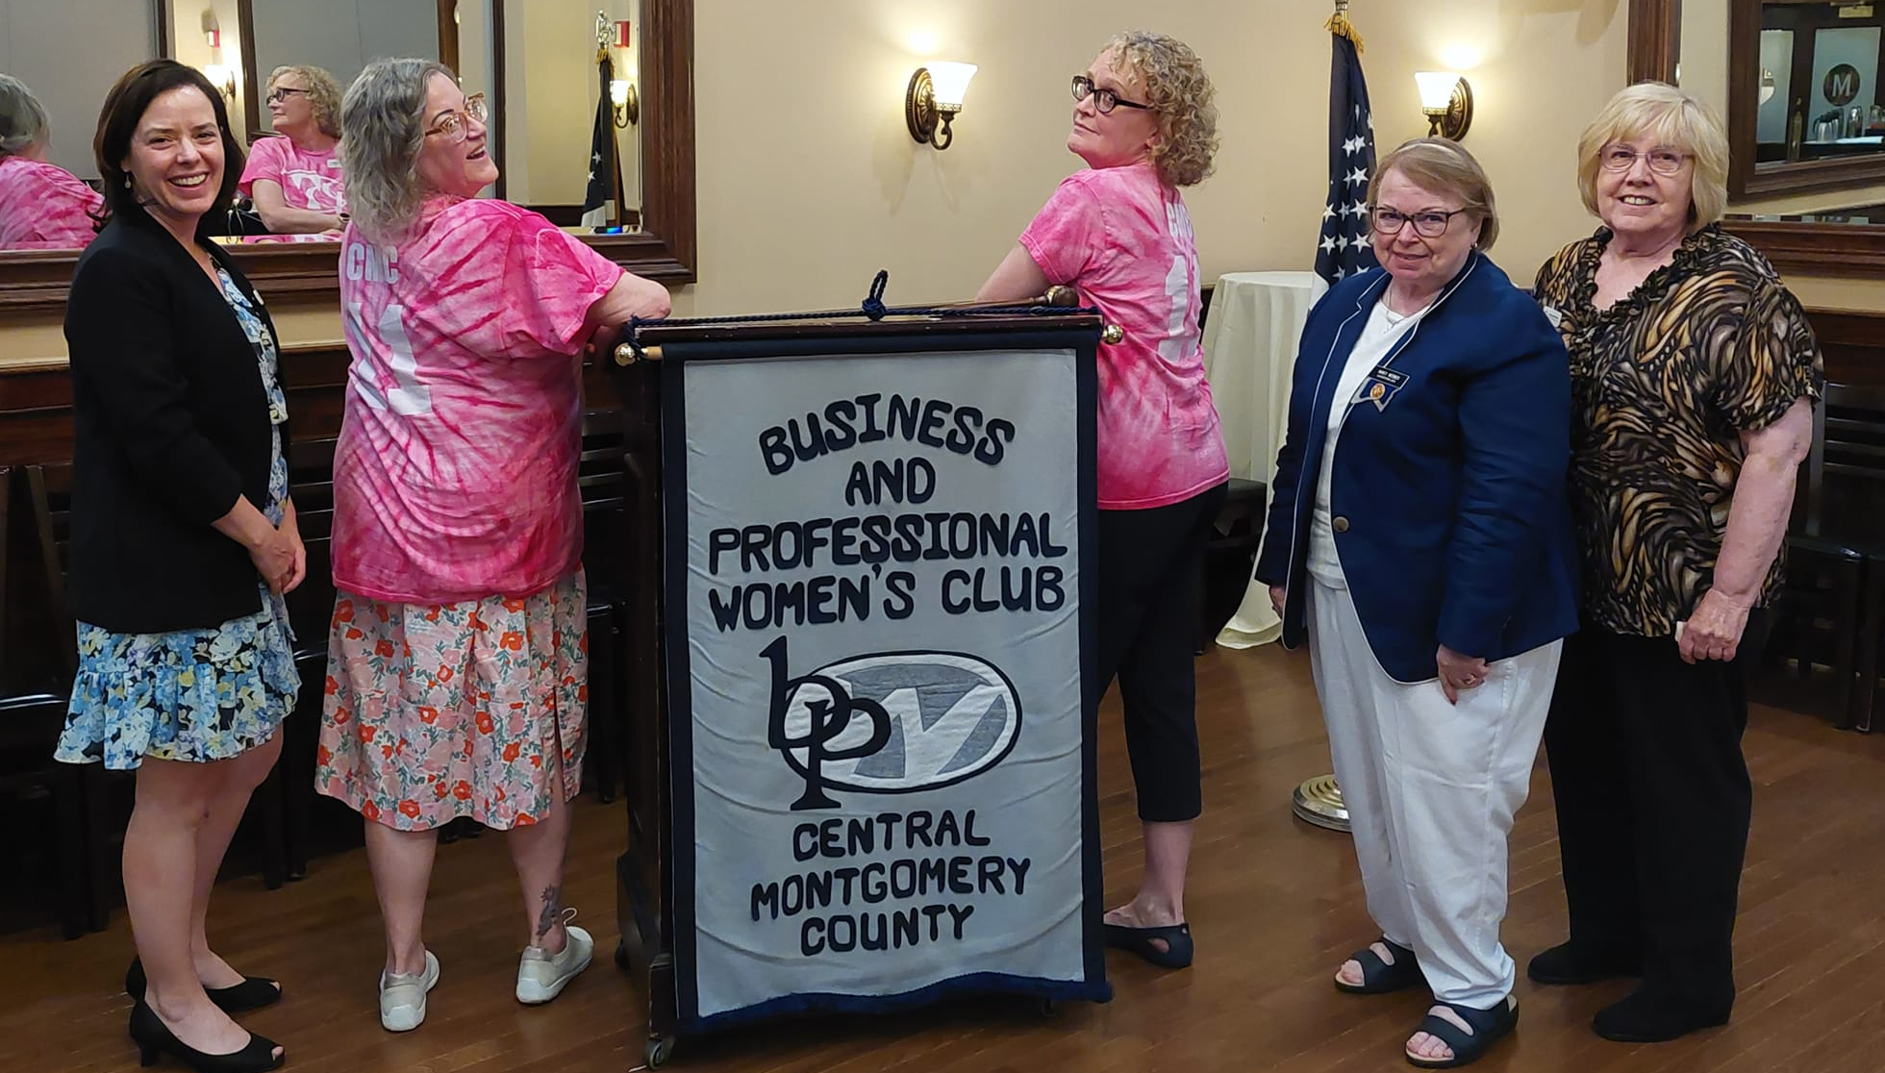
plus membership in the Montgomery County Chamber of Commerce


For all the latest, follow us on Facebook!
www.facebook.com/groups/
CentralMontgomeryCountyBPW



‘’

And visit our website:
www.centralmontgomerycountybpw.org

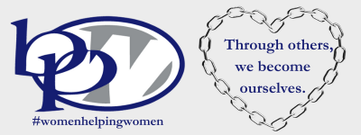

Business and

Professional

Women

Central Montgomery County PA

CMC BPW meets on the third Thursday of most months.

Join us at Maggiano’s Little Italy in King of Prussia, in

September, March, and June, and on Sunday, December 3rd,

for our annual Bingo fundraiser!

Catch up and share your news at our virtual meetings in November, February, and May.

And support other members in business, education, government, and nonprofit, at their major events throughout the year!
Dinner meetings start at 6 p.m.; lunch meetings start at noon; and virtual Zoom meetings start at 7 p.m.

